Hotel Re di Roma (3 stars)  Via Vercelli 21, Roma | 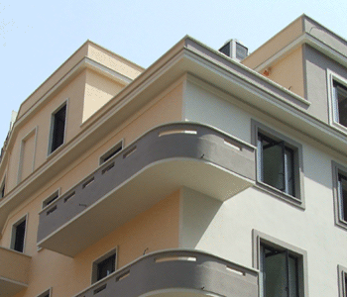
a. Rates: Double Room: € 114.
b. Distance to the venue: The hotel is less than 1 km from the subway station Re di Roma (line A). In order to get to the conference venue, take the subway till Anagnina (end of line) and take the bus 20 or 20 express till the stop “Facoltà di Economia” .
c. Booking: send the form available in the following paper to the travel agency at the following mail address (efma2014@glieventi.it). You will receive your hotel voucher in 48 hours
d. Description of hotel plus facilities:
Just 200 metres from Re di Roma Metro, this modern hotel is in Rome’s San Giovanni area. It has an elegant lounge, free Wi-Fi, and air-conditioned rooms with satellite LCD TVs.
With laptop safe boxes and natural wood furniture, rooms at the Re di Roma combine traditional and modern. Each comes with a minibar and pay-TV channels.
A buffet breakfast is served daily, and the chic bar serves international cocktails. Local food options include nearby Bar Pompi, famous for its strawberry Tiramisu dessert.
The Basilica of San Giovanni in Laterano is a 15-minute walk from the hotel. Tuscolana Station, which has direct services to Fiumicino Airport, is an 8-minute walk away.
Website: http://www.hotelrediroma.com/
European Financial Management Association
2014 Annual Meeting
June 25th – 28th, 2014
Rome, ITALY

HOTEL RESERVATION FORM
Complete with the number of Room required. Price are per room, per day and include breakfast and service
Cognome / Surname |  | Nome / Name
Indirizzo / Address
CAP / ZIP Code | Città / City |  | Prov. / Country
Telephone |  | Fax
Società / Affiliation
Data di Arrivo / Arrival date _ _ / _ _ / 2014 |  | Data di Partenza / Departure date _ _ / _ _ / 2014
Notti / Number of Nights _ _ | Accompagnato da / Guest full name ……………………………………..............

Hotel: RE DI ROMA
N. Single Rooms: |  | N. Double Rooms Single Occupancy: |  | N. Double Rooms:

I authorize the Hotel to deduct all nights price from the credit card. The rate selected does not allow modifications of cancellation.
 American Express  Mastercard / Eurocard  Visa
Numero Carta/ Card number……………………………………………………………………………………………………………………......
Titolare Carta / Card owner …………………………………………………………………………………………………………………………..
Data di Scadenza / Expiration date …………………………………………………………………………………………………………......
Numero Carta/ Card number……………………………………………………………………………………………………………………......

 I hereby authorize to add my personal details to the travel agency mailing list in accordance to the Italian legislative decree 196/2003. I may have access to my personal details at any time and I can request their modification and cancellation.

Data / Date | Firma / Signature
_ _ / _ _ / 2014 | ………………………………………………………………………………

Please send the reservation form to efma2014@glieventi.it and you will receive the Hotel voucher in 48 hours.

